
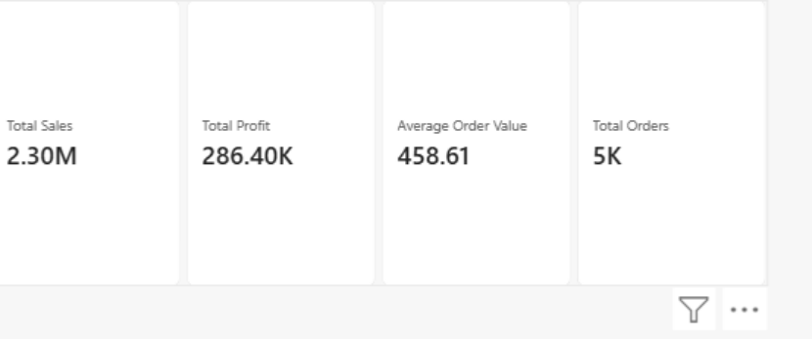
LAB SHEET 5
Experiment Name - > Interactive Dashboard Development using Tableau /
Microsoft Power BI
Steps : 1. Download and install Tableau Public or Microsoft Power BI Desktop.
2. Import a real-world dataset such as the Superstore Sales Dataset, Global
Superstore Dataset, or Amazon Sales Dataset.
3. Verify the imported data by checking field names, data types, and
relationships between tables (if applicable).
4. Create Key Performance Indicators (KPIs) such as Total Sales, Total Profit,
Number of Orders, Average Order Value, or Customer Count.
5. Develop multiple visualizations, such as bar charts, line charts, pie charts,
maps, and treemaps, to analyze business performance from different
perspectives.
6. Add interactive filters, slicers, and drill-down features to allow users to
explore the data by region, product category, customer segment, or time
period.
7. Arrange all visualizations into a professional dashboard with appropriate
titles, formatting, and layout.
8. Analyze the dashboard to identify business trends, top-performing products,
high-revenue regions, and areas requiring improvement.
9. Publish or export the dashboard for presentation and sharing with
stakeholders.
10. Prepare a brief report summarizing the key business insights obtained
from the dashboard.
Solutions->4) KPI Cards of Totals Sales, Total Profit, Number of
Orders(Total Orders) and Average Order Value

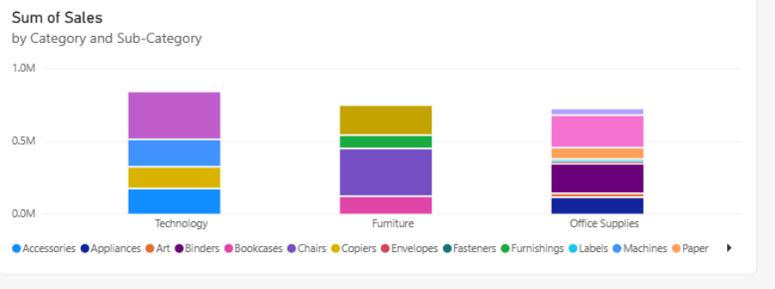
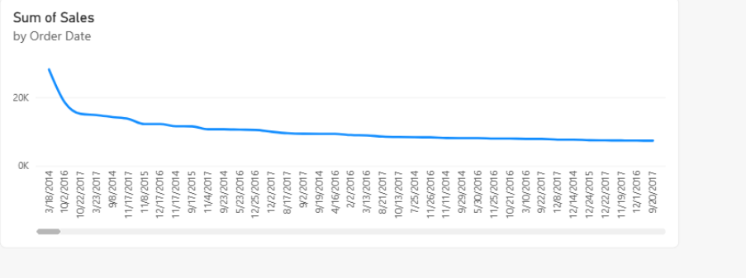
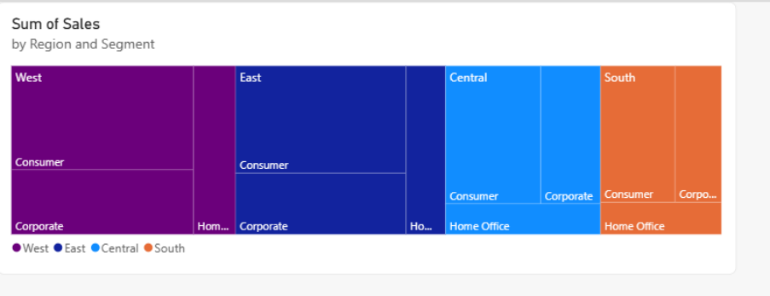
5) 1: Stacked Column Chart (Sales by Category & Sub-Category)
2: Line Chart (Sales Trend over Time)
3: Treemaps
4: Pie charts

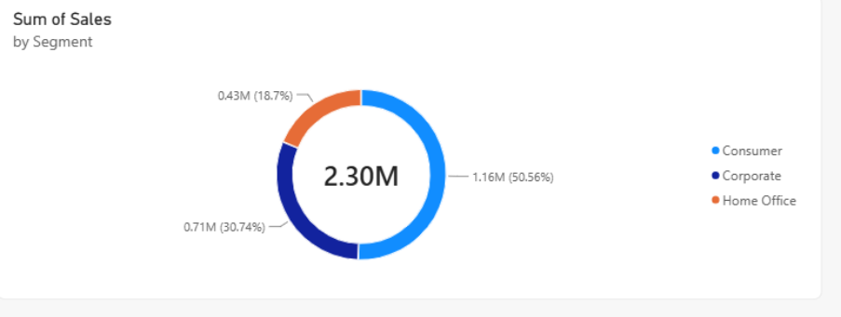
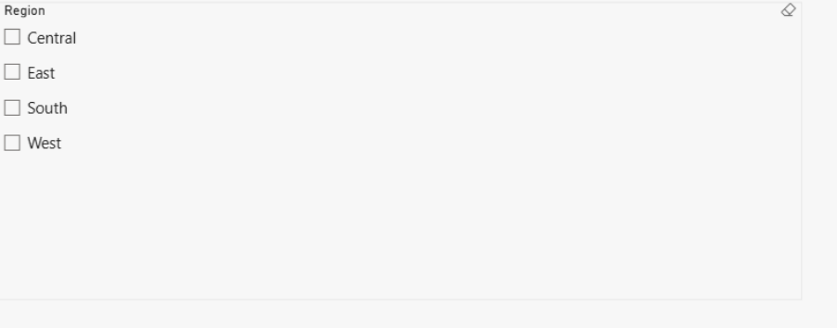
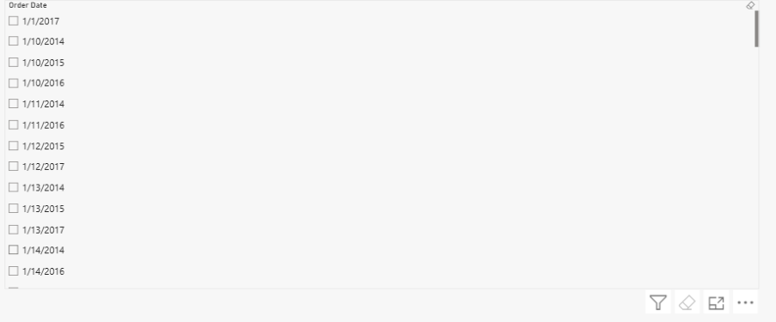
6) 1: Region Slicer
2: Data Range Slicer

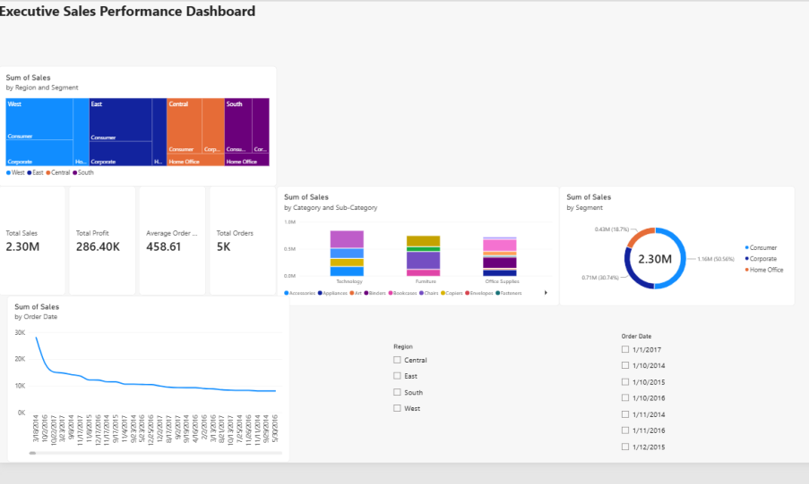
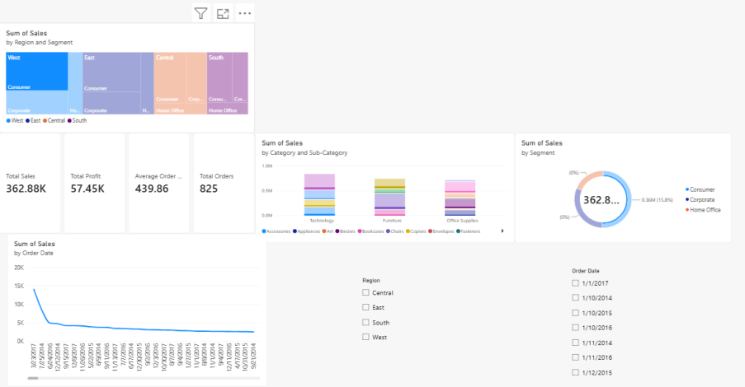
7)
8) 1: Analyze High-Revenue Regions & Customer Segments
2: Identify Top-Performing Categories & Sub-Categories

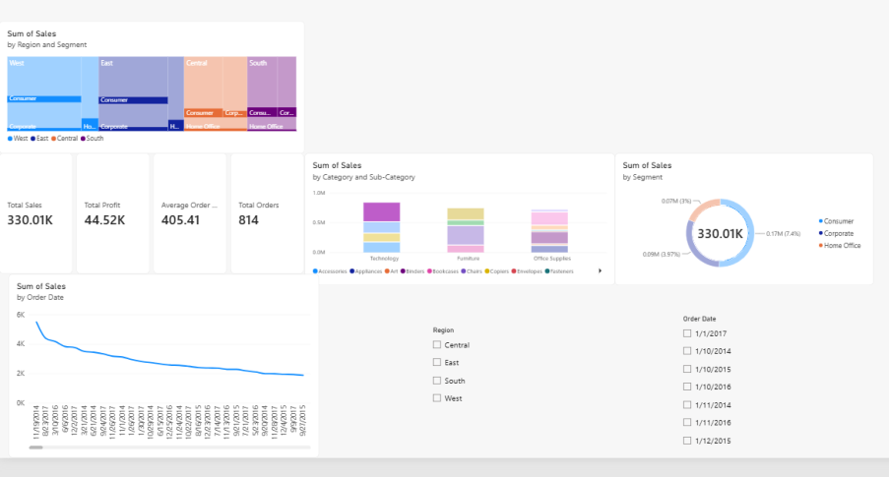
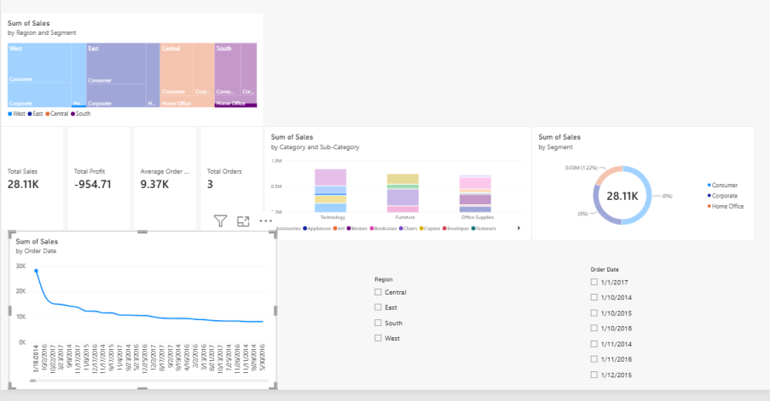
3: Analyze Sales Trends & Seasonality
4: Identify Areas Requiring Improvement

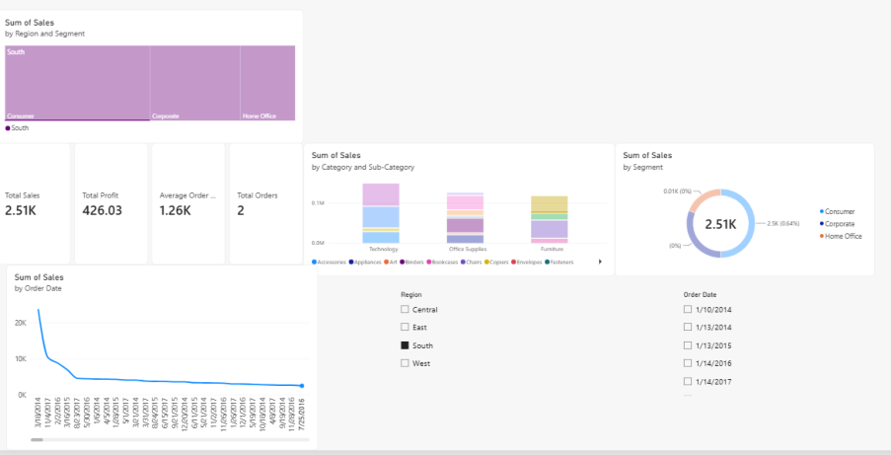
10) Executive Insights Report
●​ Overall Performance: Generated $2.30M in Total Sales across 5K
Total Orders with a cumulative profit of $286.40K.
●​ Top Sales Driver: Technology and Furniture categories dominate
overall revenue, with high customer concentration in the Consumer
segment.
●​ Regional & Seasonal Patterns: Sales consistently peak towards the
end of the year (Q4), driven primarily by strong performance in major
metropolitan regions.
●​ Actionable Recommendation: Reallocate marketing budget toward
high-margin sub-categories and investigate low-performing regions to
optimize discount strategies.
Questions
1. What is Business Intelligence (BI)? How does it support organizational
decision-making?
2. What is an interactive dashboard? How is it different from a static report?
3. Compare Tableau and Microsoft Power BI based on features, usability, and
business applications.
4. What are Key Performance Indicators (KPIs)? Give examples of KPIs used in
sales analytics.
5. Explain the purpose of filters, slicers, and drill-down functionality in dashboards.
6. What factors should be considered while designing an effective business
dashboard?
7. How can dashboards help managers monitor organizational performance in real
time?
8. Why is data visualization important in Business Intelligence tools?

9. What insights can be derived from a sales dashboard for an e-commerce
company?
10. Explain how interactive dashboards improve communication between data
analysts and business stakeholders.
Answers: 1: Business Intelligence (BI) is the process of collecting,
analyzing, and presenting business data to help organizations make informed
decisions.
How BI supports decision-making:
●​ Converts raw data into meaningful information.
●​ Helps identify trends and patterns.
●​ Provides reports and dashboards for monitoring performance.
●​ Supports forecasting and planning.
●​ Helps managers make faster, data-driven decisions.
●​ Identifies problems and opportunities in business operations.
Example: A company can use BI to analyze sales data and identify which
products and regions generate the highest revenue.
2: An interactive dashboard is a visual interface that allows users to explore
data using filters, slicers, drill-downs, and other interactive features.
Interactive Dashboard Static Report
Users can interact with the data. Information is fixed.
Supports filters and slicers. Usually has limited interaction.
Data can be explored at different Usually displays predefined
levels. information.
Can provide dynamic Usually consists of fixed
visualizations. tables/charts.
Useful for analysis and Useful for presenting finalized
monitoring. information.
Example: In Power BI, selecting a particular region in a sales chart can
automatically update other charts and KPI cards.
3:
Feature | Tableau | Microsoft Power BI

Developer | Salesforce | Microsoft

Visualization | Strong and highly | Strong and easy to use

customizable
Usability | Requires some learning for | Generally beginner-friendly

advanced features
Data Sources | Supports many data | Supports many data sources

sources
Dashboarding | Advanced interactive | Interactive dashboards and

dashboards reports
Integration | Strong Salesforce and | Strong Microsoft/Excel/Azure

external integrations integration
Data Analysis | Powerful visual analytics | Strong analytics with DAX

Business | Data exploration, analytics, | Reporting, business analytics,

Applications | enterprise BI | KPI monitoring

4: Key Performance Indicators (KPIs) are measurable values used to
evaluate the performance or progress of a business, department, or activity
toward a specific objective.
Examples of sales KPIs:
●​ Total Sales: Total revenue generated from sales.
●​ Total Orders: Number of orders received.
●​ Average Order Value (AOV): Average amount spent per order.
●​ Profit: Revenue remaining after expenses.
●​ Sales Growth Rate: Percentage increase or decrease in sales over
time.
●​ Conversion Rate: Percentage of potential customers who become
buyers.
●​ Customer Acquisition Cost (CAC): Cost of acquiring a new customer.
5: Filters:​
Filters restrict the displayed data according to selected conditions.
Example: Showing sales only for the year 2025.

Slicers:​
Slicers are visual filtering controls that allow users to select values directly
from a dashboard.
Example: Selecting the West Region from a Region slicer.
Drill-down:​
Drill-down allows users to move from summarized information to more
detailed information.
Example:
Year → Quarter → Month → Day
A manager can first view yearly sales and then drill down to monthly or daily
sales.
6: The following factors should be considered:
1.​ Clear objective – Define what business problem the dashboard should
solve.
2.​ Target audience – Design according to the needs of managers,
analysts, or executives.
3.​ Relevant KPIs – Display only important performance indicators.
4.​ Simple layout – Avoid unnecessary charts and information.
5.​ Appropriate visualizations – Select charts suitable for the type of
data.
6.​ Consistency – Use consistent labels, units, and formatting.
7.​ Interactivity – Include useful filters, slicers, and drill-downs.
8.​ Data accuracy – Ensure that the underlying data is reliable.
9.​ Performance – Dashboard should load and respond quickly.
10.​ Readability – Make important information easy to understand.
7: Dashboards can connect to frequently updated data sources and display
the latest available information.
They help managers by:
●​ Monitoring important KPIs.
●​ Tracking sales, revenue, profit, and expenses.
●​ Detecting unusual changes or problems.
●​ Comparing current performance with targets.
●​ Monitoring different departments or regions.

●​ Supporting faster operational decisions.
●​ Providing a centralized view of business performance.
Example: An e-commerce manager can monitor today's orders, revenue,
inventory levels, and sales by region from a single dashboard.
The exact meaning of "real time" depends on how frequently the
underlying data source refreshes.
8: Data visualization represents data using charts, graphs, maps, and other
visual elements.
It is important because it:
●​ Makes complex data easier to understand.
●​ Helps identify trends and patterns quickly.
●​ Makes comparisons easier.
●​ Highlights unusual values and problems.
●​ Supports faster decision-making.
●​ Improves communication of analytical results.
●​ Helps users understand large datasets without examining raw tables.
Example: A line chart can quickly show whether monthly sales are increasing
or decreasing.
9: A sales dashboard can provide several important insights, such as:
●​ Total sales and revenue generated.
●​ Number of orders received.
●​ Average Order Value (AOV).
●​ Top-selling products.
●​ Low-performing products.
●​ Sales trends over time.
●​ Sales by region or location.
●​ Profit and profit margin.
●​ Customer purchasing patterns.
●​ Category-wise sales performance.
●​ Comparison between actual sales and sales targets.
Example: If a dashboard shows that one product category generates high
sales but low profit margins, management can investigate its pricing and
costs.

10: Interactive dashboards provide a common visual platform where
analysts and business stakeholders can examine the same data.
They improve communication by:
1.​ Making data easier to understand through charts and KPI cards.
2.​ Reducing dependence on technical reports and complex
spreadsheets.
3.​ Allowing stakeholders to explore data themselves using filters and
slicers.
4.​ Supporting discussions based on the same data.
5.​ Making trends and problems easier to identify.
6.​ Allowing users to drill down when more detail is required.
7.​ Providing faster answers to business questions.
8.​ Improving collaboration between analysts, managers, and
decision-makers.

